Product Requirements Document (PRD)

Feature: Reel Circles

Product: Instagram

Product Area: Reels + Communities

Prepared By: Aman raj

Status: Proposal

1. Executive Summary
Reel Circles is a community-driven feature integrated directly into Instagram Reels that enables users to join topic-based micro-communities around specific interests.
Today, Reels are optimized heavily for discovery and short-term engagement, but they lack persistent social interaction and community identity. Users consume content rapidly but often fail to build deeper connections around shared interests.
Reel Circles solves this problem by creating small interest hubs attached to Reels, creators, trends, or topics.
Examples:
- Fitness Reels → Home Workout Circle
- Photography Reels → Street Photography Circle
- Anime Reels → Anime Theory Circle
- Travel Reels → Solo Backpackers Circle
- Coding Reels → Python Learners Circle
Users can:
- Join circles
- Discuss topics
- Share related reels
- Participating in challenges
- Discover people with similar interests
- Attend creator-led sessions
- Build long-term engagement beyond likes/comments
This feature transforms Instagram from a passive content consumption platform into a deeper interest-based social ecosystem.

2. Problem Statement

Current User Problems

For Users
Problem | Description
Shallow interactions | Reels engagement ends after viewing
Weak community feeling | Users cannot connect deeply over niche interests
Poor discussion quality | Comments are noisy and difficult to follow
Content overload | Users consume but rarely retain communities
Difficult discovery | Hard to find people with same interests

For Creators
Problem | Description
Low retention | Viral viewers rarely become loyal followers
Weak fan communities | No structured community-building tools
Limited engagement depth | Comments and likes are low context
Fragmented audience | Followers scattered across multiple platforms

For Instagram Business Goals
Goal | Current Gap
Improve retention | Users’ open instagram frequently but leave quickly
Increase meaningful engagement | Passive scrolling dominates behavior
Improve creator loyalty | Creators depend on external communities
Increase ad inventory quality | Communities enable high-intent targeting

3. Product Vision
Create persistent interest-driven micro-communities directly inside Instagram Reels.
Reel Circles should make Instagram feel like:
- TikTok-level discovery
- Discord-style communities
- Reddit-like discussions
- Instagram-native social interactions
All combined into one seamless experience.

4. Goals & Success Metrics

Primary Goals
- Increase meaningful interactions
- Improve creator retention
- Increase user session quality
- Build long-term communities
- Increase Reel save/share behavior

5. User Personas

Persona 1 — Casual Viewer

Example
Riya watches skincare and fashion reels daily.

Needs
- Find users with same interests
- Get curated recommendations
- Participate in trends

Benefit from Reel Circles
She joins a “Minimal Makeup Circle” and starts discovering relevant creators and tutorials.

Persona 2 — Creator

Example
Arjun posts calisthenics reels.

Needs
- Build loyal community
- Increase repeat viewers
- Monetize audience

Benefit from Reel Circles
He creates a “90-Day Transformation Circle” with challenges and weekly livestreams.

Persona 3 — Learner/Hobbyist

Example
Aman wants to learn video editing.

Needs
- Structured discussions
- Peer support
- Shared resources

Benefit
He joins an “Editing Mastery Circle” and shares projects with others.

6. Feature Overview

What is a Reel Circle?
A Reel Circle is a topic-focused micro-community attached to:
- A Reel
- A Creator
- A Trend
- A Hashtag
- An AI-generated interest cluster
Each circle contains:
- Discussion Feed
- Shared Reels
- Challenges
- Polls
- Events/Lives
- Creator Announcements

7. Where Will This Feature Exist?

A. Reel Player Screen

Placement
Directly below:
- Like button
- Comment button
- Share button
New Button:
“Join Circle”

Example UI

❤️ 24K
💬 2.1K
📤 Share
⭕ Join Circle

B. Explore Page
New Recommendation Section:
“Circles You Might Like”
Powered by:
- Watch history
- Saves
- Shares
- Interaction behavior

C. Search
Users can search:
- Fitness Circles
- Anime Circles
- Startup Circles
- Photography Circles

8. User Access Flow

Joining a Circle
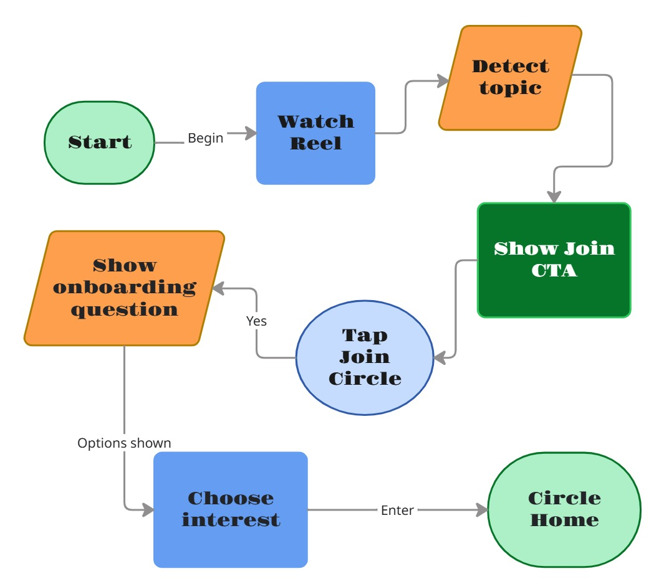

Accessing Existing Circles
Users can access circles through:
Entry Point | Location
Reel Screen | Join button
Profile Tab | Creator profile
Explore Feed | Recommended circles
Search | Search results
Notifications | Circle activity
Shared Link | Direct invite

9. User Experience Journey

Example Journey
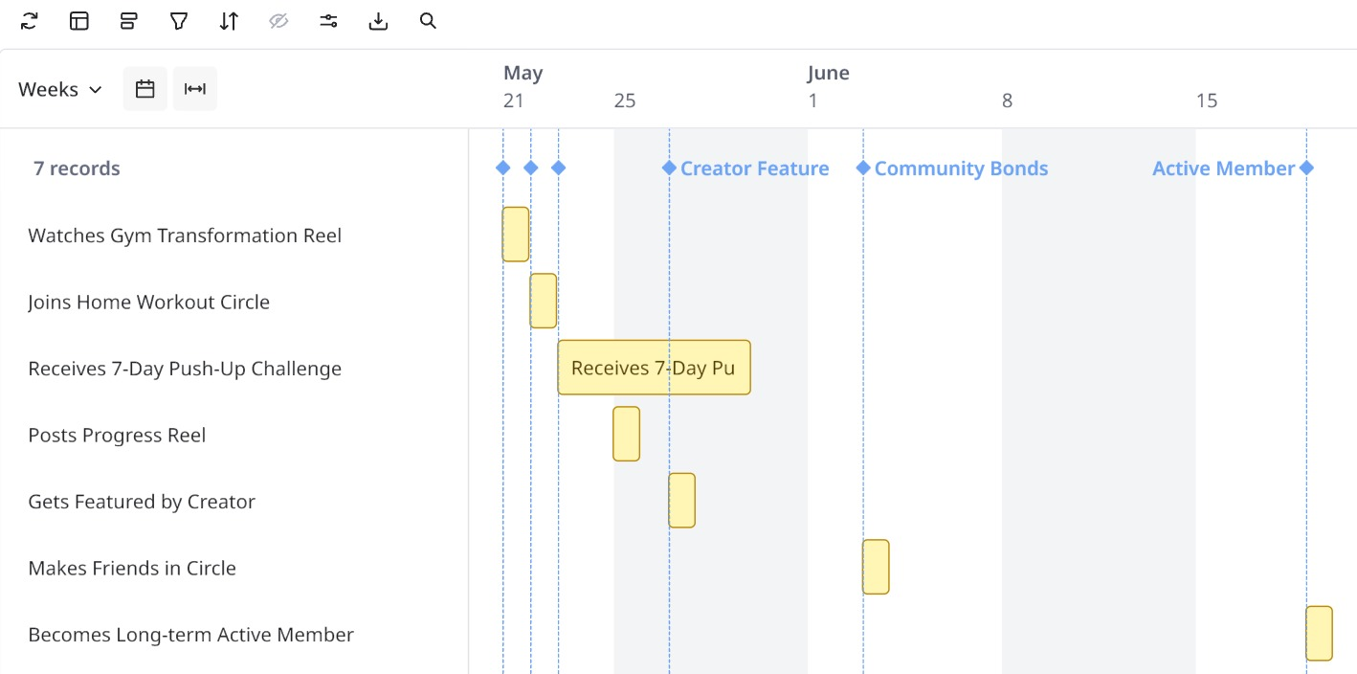

10. Core Features

Feature 1 — Circle Feed
A dedicated feed inside the Circle.
Includes:
- Related Reels
- Member posts
- Discussions
- Polls
- Announcements

Feature 2 — Challenges
Creators can launch:
- Fitness challenges
- Photography contests
- Editing competitions
- Learning streaks

Users earn:
- Badges
- Streaks
- Visibility boosts

Feature 3 — Shared Boards
Members collaboratively save:
- Reels
- Tutorials
- References
- Inspirations
Example:
“Best Beginner Coding Reels.”

Feature 4 — Voice Rooms
Temporary audio discussions.
Examples:
- Anime discussion night
- Fitness Q&A
- Creator AMA

Feature 5 — Circle Levels & Reputation
Users earn reputation points through:
- Helpful comments
- Challenge participation
- Content sharing
Levels:
- Beginner
- Contributor
- Expert
- Moderator

Feature 6 — AI Recommendations
Instagram AI suggests:
- Similar circles
- Related creators
- Relevant challenges
- Personalized discussions

11. Circle Creation Logic

Who Can Create Circles?

Phase 1
- Verified creators
- 10K+ followers

Phase 2
- All creators

Phase 3
- Community-created circles

AI-Generated Circles
Instagram automatically generates circles using:
- Captions
- Hashtags
- Audio
- Viewer interactions
- Watch patterns
Example:
A Reel tagged:
#gym #fatloss #fitness
AI suggests:
- Fat Loss Circle
- Beginner Fitness Circle
- Home Workout Circle

12. How Users Can Leave or Stop the Feature
This section is critical to prevent user frustration and notification fatigue.

Leaving a Circle
Inside Circle Settings:
Options:
- Leave Circle
- Mute Notifications
- Hide Recommendations
- Pause Circle Suggestions

Stop Feature Recommendations
Users can disable Reel Circles completely.
Path:
Settings → Content Preferences → Reel Circles
Controls:
- Disable Join Suggestions
- Disable Circle Notifications
- Disable Personalized Circle Recommendations
- Hide Circle Feed Integration

Temporary Pause Option
Users can pause circles for:
- 7 Days
- 30 Days
- Permanently
This reduces overload.

Notification Controls
Users can customize:
Notification Type | Control
Challenge reminders | ON/OFF
Creator announcements | ON/OFF
Mentions | ON/OFF
Trending discussions | ON/OFF
Weekly summaries | ON/OFF

13. Detailed UX Design Concepts

Circle Home Screen
Contains:
- Circle Banner
- Creator Intro
- Member Count
- Challenge Section
- Discussion Tabs
- Shared Reels
- Events

Tabs Structure
Tab | Purpose
Feed | Community updates
Reels | Related videos
Challenges | Active challenges
Members | Community list
Events | Live sessions

14. Moderation & Safety

Risks
Risk | Description
Toxic communities | Hate or harassment
Spam circles | Low-quality engagement farming
Fake challenges | Unsafe trends
Misinformation | Harmful advice

Moderation Systems

AI Moderation
Detect:
- Toxicity
- Hate speech
- Spam
- Dangerous content

Human Moderators
Large circles receive:
- Community moderators
- Escalation systems

Creator Controls
Creators can:
- Ban members
- Restrict comments
- Approve posts
- Lock discussions

15. Technical Architecture

Core Systems Required
System | Requirement
Recommendation Engine | Circle recommendations
Topic Clustering | AI-generated interests
Moderation Pipeline | Safety filtering
Notification Engine | Circle alerts
Group Infrastructure | Community interactions

Scalability Requirements
Potential scale:
- Hundreds of millions of circles
- Billions of interactions monthly
Requires:
- Distributed storage
- Real-time feed ranking
- AI inference infrastructure

16. Data & Machine Learning

ML Models Required
Model | Purpose
Interest Classification | Topic mapping
Toxicity Detection | Safety
Recommendation Ranking | Circle suggestions
Engagement Prediction | Prioritize quality circles
Churn Prediction | Detect inactive users

17. Monetization Opportunities

Sponsored Circles
Brands create communities.
Examples:
- Nike Running Circle
- Adobe Editing Circle
- Samsung Photography Circle

Premium Creator Circles
Subscription-based communities.
Features:
- Exclusive tutorials
- Private livestreams
- VIP discussions

Targeted Ads
Higher intent targeting due to strong interest signals.
Example:
Users in “Photography Circle” receive camera ads.

18. Competitive Advantage
Competitor | Weakness
TikTok | Weak community persistence
Discord | Weak discovery
Reddit | Weak creator monetization
YouTube | Slower short-form engagement
Reel Circles combines:
- Discovery
- Community
- Monetization
- Creator ecosystems
In one platform.

19. Rollout Plan

Phase 1 — Internal Testing
Audience:
- Employees
- Selected creators
Goals:
- Test moderation
- Measure engagement

Phase 2 — Beta Launch
Markets:
- India
- US
- Brazil
Focus:
- Fitness
- Gaming
- Fashion
- Education

Phase 3 — Public Launch
Global rollout.
Marketing campaigns:
- “Find Your People”
- “Communities Around What You Love”

20. Success Criteria
Feature considered successful if:
KPI | Success Threshold
30-Day Circle Retention | >40%
Average Circle Sessions/User | 5 per week
Challenge Participation | >20%
Creator Adoption Rate | >35%
User Satisfaction Score | >80%

21. Long-Term Vision
Reel Circles evolves Instagram from:
- Content-first platform
Into:
- Interest-first social ecosystem.
Future possibilities:
- AI mentors inside circles
- Circle marketplaces
- Collaborative creator projects
- Community commerce
- Skill-based communities
- Offline event integration

22. Final Recommendation
Reel Circles has the potential to become one of Instagram’s most important engagement features because it addresses a major structural weakness in short-form content platforms:
“Discovery without belonging.”
By combining:
- Reels
- Communities
- AI recommendations
- Creator monetization
- Structured engagement
Instagram can significantly improve:
- Retention
- Session quality
- Creator loyalty
- Revenue opportunities
- User satisfaction
while building a stronger long-term social ecosystem.

23. User Stories

Viewer User Stories

Story 1 — Join a Circle
As a user,
I want to join a Reel Circle from a Reel,
so that I can connect with people interested in the same topic.

Acceptance Criteria
- “Join Circle” CTA visible on eligible Reels
- Joining takes less than 2 taps
- User receives onboarding recommendations
- Circle appears in profile instantly

Story 2 — Participate in Challenges
As a member,
I want to participate in circle challenges,
so that I can stay engaged and improve my skills.

Acceptance Criteria
- Challenge tab visible inside Circle
- Progress tracking available
- Rewards/badges shown clearly

Story 3 — Mute Notifications
As a user,
I want to mute a Circle,
so that I can avoid notification overload without leaving the community.

Acceptance Criteria
- Mute option accessible in settings
- Notifications stop immediately
- Membership remains active

Creator User Stories

Story 4 — Launch a community
As a creator,
I want to create and manage a Circle,
so that I can build a loyal audience around my niche.

Acceptance Criteria
- Creator dashboard available
- Analytics accessible
- Moderation tools functional

Story 5 — Host Events
As a creator,
I want to host live discussions and events,
so that I can interact deeply with my audience.

Acceptance Criteria
- Event scheduling available
- Notifications sent automatically
- Replay accessible afterward

24. Functional Requirements

Circle Feed
Requirement ID | Description
FR-001 | Users can create posts within circles
FR-002 | Users can comment/reply in threaded format
FR-003 | Feed refreshes in real-time
FR-004 | AI prioritizes high-quality discussions

Join Flow
Requirement ID | Description
FR-005 | Users can join with one tap
FR-006 | AI recommends circles contextually
FR-007 | Users can leave anytime
FR-008 | Users can hide future recommendations

Challenges
Requirement ID | Description
FR-009 | Creators can create timed challenges
FR-010 | Progress tracking supported
FR-011 | Challenge reminders configurable
FR-012 | Rewards system integrated

Moderation
Requirement ID | Description
FR-013 | AI moderation scans all discussions
FR-014 | Users can report content
FR-015 | Creators can remove members
FR-016 | Harmful challenges automatically flagged

25. Non-Functional Requirements
Category | Requirement
Performance | Circle feed loads under 2 seconds
Scalability | Support 100M+ active circles
Reliability | 99.9% uptime
Security | End-to-end encrypted DMs for circle chats
Privacy | GDPR & regional compliance
Accessibility | Screen-reader support and captions

26. Analytics & Tracking

Key Events to Track
Event | Description
Circle_Join | User joins a circle
Circle_Leave | User exits a circle
Challenge_Start | User joins challenge
Challenge_Complete | User finishes challenge
Circle_Post_Create | Member creates discussion
Circle_Reel_Share | Reel shared into circle

Funnel Analysis

Example Funnel
Reel View → Join CTA Click → Circle Join → Challenge Participation → Weekly Retention

27. Recommendation Algorithm Logic

Inputs Used
Instagram AI recommendation engine will use:
- Reel watch duration
- Rewatch frequency
- Saves
- Shares
- Likes
- Comments
- Follow graph
- Audio preferences
- Search history
- Challenge participation

Ranking Priorities
Priority | Weight
Shared Interest Match | High
Circle Activity Level | High
Friend Participation | Medium
Creator Affinity | Medium
Trending Status | Low

28. Gamification System

Reputation Points
Users earn points through:
Action | Points
Helpful reply | +5
Challenge completion | +20
Reel contribution | +10
Community moderation help | +15

Badge Examples
Badge | Requirement
Early Member | Joined within first week
Challenge Champion | Completed 10 challenges
Top Contributor | High engagement score
Community Mentor | Frequently helps members

29. Creator Dashboard

Creator Controls
Creators can:
- Pin posts
- Launch announcements
- Schedule events
- Create challenges
- View analytics
- Moderate members

Analytics Available
Metric | Description
Active Members | Daily active participants
Retention | Returning users
Challenge Completion | Participation rate
Top Discussions | Most engaging topics
Growth Rate | New member growth

30. Privacy & Safety Framework

Privacy Controls
Users can choose:
Option | Description
Public Circle | Anyone can join
Approval-Based Circle | Requires creator approval
Private Circle | Invite-only

Safety Systems

AI Detection
Automatic removal of:
- Hate speech
- Bullying
- Extremism
- Self-harm content
- Spam links

Teen Safety
For underage users:
- Restricted DMs
- Stronger moderation
- Limited discoverability
- Safe challenge filters

31. UX Wireframe Concepts

Reel Screen
--------------------------------
| Reel Video |
| |
| ❤️ 24K |
| 💬 2.1K |
| 📤 Share |
| ⭕ Join Circle |
--------------------------------

Circle Home
--------------------------------
| Home Workout Circle |
| 12.8K Members |
--------------------------------
| Feed | Reels | Challenges |
--------------------------------
| Today's Challenge |
| Member Discussions |
| Shared Reels |
--------------------------------

32. A/B Testing Strategy

Experiment 1 — CTA Placement

Variant A
Button below Share icon

Variant B
Floating animated chip

Success Metric
Higher Join Conversion Rate

Experiment 2 — Circle Recommendation Timing

Variant A
Recommendation immediately after Reel

Variant B
Recommendation after multiple Reel interactions

Success Metric
Lower annoyance + higher retention

33. Potential Risks & Mitigation
Risk | Severity | Mitigation
Notification fatigue | High | Advanced controls
Toxic discussions | High | AI moderation
Low creator adoption | Medium | Incentivize early creators
Community fragmentation | Medium | Smart recommendation merging
Spam growth | High | Rate limiting + verification

34. Dependencies

Internal Dependencies
Team | Responsibility
Reels Team | Reel integration
AI/ML Team | Recommendation systems
Messaging Team | Community chat
Moderation Team | Safety systems
Design Team | UI/UX
Infrastructure Team | Scalability

35. Estimated Timeline
Phase | Duration
Research & Validation | 4 weeks
UX Design | 3 weeks
Backend Development | 10 weeks
ML Systems | 8 weeks
Internal QA | 3 weeks
Beta Launch | 4 weeks
Global Rollout | 6 weeks
Estimated Total:
~6–8 months

36. Launch Strategy

Launch Campaign

Marketing Tagline
“Turn Reels Into Real Communities.”

Influencer Rollout
Partner with:
- Fitness creators
- Study creators
- Gaming creators
- Fashion influencers

In-App Promotions
- Explore page banners
- Reels onboarding cards
- Creator promotion prompts

37. Revenue Forecast
Revenue Stream | Estimated Annual Impact
Sponsored Circles | $150M
Premium Communities | $200M
Higher Ad Targeting Efficiency | $300M
Creator Monetization Share | $100M
Estimated Total Opportunity:
$750M+ annually

38. KPI Dashboard

Executive Dashboard Metrics
KPI | Goal
Daily Circle Active Users | 25M
Weekly Retention | >45%
Average Time in Circles | 18 min/day
Creator Participation | >35%
Reported Toxicity Rate | <1%

39. Future Expansion Opportunities

Phase 2 Ideas
- AI-generated discussion summaries
- Community AI assistants
- Circle NFTs/badges
- Offline meetup integration
- Collaborative creator projects
- Learning-based circles
- Shopping communities

40. Conclusion
Reel Circles solves one of the biggest weaknesses in short-form content platforms:
Users discover content, but they rarely build lasting relationships around it.
This feature transforms Instagram Reels from:
- A passive entertainment feed
into:
- An active, interest-driven social ecosystem.
The feature combines:
- Discovery
- Community
- Gamification
- AI personalization
- Creator monetization
while improving:
- Retention
- User satisfaction
- Session quality
- Creator loyalty
- Revenue potential
Reel Circles has the potential to become Instagram’s next major platform-defining feature by creating persistent digital communities directly around short-form content consumption.

